**Capstone Project: Find the best place to open a gym in Bogotá, Colombia**

Bogotá is the capital of Colombia, a country with an expected GDP growth of 7% by 2021, with a young population that has become aware of the importance of healthy lifestyles in the midst of economic growth.

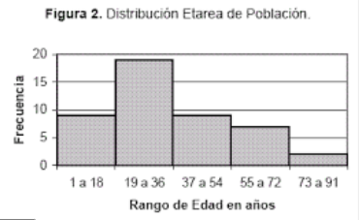

This is why my friend has identified a business opportunity by opening gymnasiums in strategic places in the city, which are beginning to be identified as areas where to find these types of establishments. However, it is not clear to find the best areas to start the study, therefore it is proposed to carry out a Data Science exercise to make use of machine learning and clusterig tools to deliver a solution that takes into account the configuration of the city and how it has been done. been developing.

